Lamp Identification Form
This form is also available on our website at: www.pguvlamps.com

For a quotation, please complete the following form and email to:
xxxxxxx@pguvlamps.com.

Company Name Department
Contact address
XXXXX
Street No.
City Country
Phone / Fax /
Send
Email @

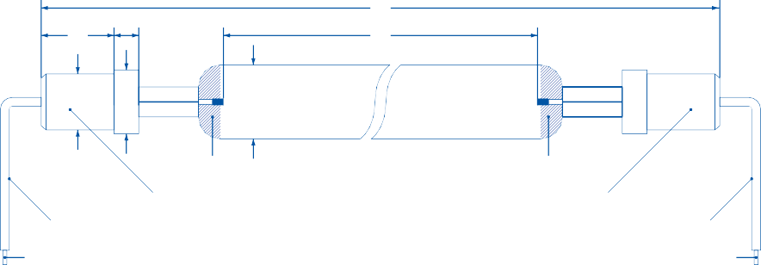Identification of your UV-Lamp
a
b
1
2
c d
3
6
5 End cap
4 Cable side A
7 Lamp cable connector
6
5 End cap
4 Cable side B
7 Lamp cable connector

7 Lamp Cable Connector: Wire end sleeve
Ring lug, D mm

No cables

Fork connector, D mm Female push-on
connector, D mm
Other, attach drawing or photo

Mechanical Data of the UV-Lamp
- Total length mm
- Arc length mm

Quartz Type
Standard Ozone-free Synthetic

- Diameter
Ø mm
Other:

- Cable length: side A mm side B mm

- End cap:
metal ceramic
Spectrum

  - mm
  - mm
Hg (Mercury) Ga (Gallium) Gi (Gallium-Indium)

c Ø mm
d Ø mm
Fe (Iron)
other:

other, attach drawing or photo

- Reflector:
none
gold silver white
Electrical Data of the UV-Lamp
Lamp voltage V

Lamp current A

Electrical Data of the Power Supply
Primary voltage V Secondary voltage V No-load voltage V
Lamp power: Total

Additional Information
W Specific
W/cm

Type of power supply (check all that applies): Chokes & Igniter Stray field transformer Constant wattage transformer
Step-up transformer with chokes & igniter Electronic power supply
Thyristor controller Transductor controller
Specify your application Lamp type Yearly demand Producer of lamp Your UV-curing system made by

Local mains voltage V
50 Hz 60 Hz
UV-curing system type

Operation:
phase-to-phase phase-to-ground
Your machine made by Machine type

